

Asset Practice Questions: Science

**1. Two vessels are connected as shown below. First, when the tap is closed, only one of them has water.**

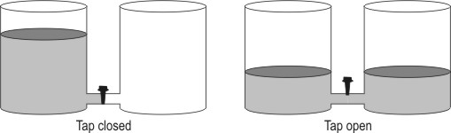**After the tap is opened, there is water in both the vessels.**

**What can we say about the total amount of water after opening the tap? A.** It is the same because no water has been poured in or out at all.

**B.** It is more because now there is water in both the vessels.

**C.** It is less because the height of the water in the vessels has come down.

**D.** We cannot say anything without measuring the amounts of water in both cases.

**2. Study the figure given below. Which of the blocks shown is the heaviest?**

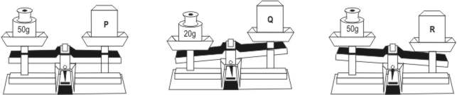

**A.** P

**B.** Q

**C.** R

**D.** Can’t determine

**3. Based on who eats whom, the organisms can be arranged in a particular order. For example, in the image below, a deer eats grass and a tiger eats deer.**



**In which of the following are the organisms arranged correctly in this order?**

**A.** Frog -> Snake -> Owl

**B.** Wolf -> Rabbit -> Lion

**C.** Cat -> Mouse -> Spider

**D.** Snake -> Rat -> Peacock

**4. Priyam found a bird that**

**• eats grains and cooked food**

**• avoids hawks and falcons, as it is the food for them**

**• prefers narrow sheltered spaces for nesting, as it does not build a big nest**

**The home of this bird is most likely to be ____________.**

**A.** on a high branch of a tree that is open to the sky

**B.** on the soft sand beside a pond

**C.** in an isolated cave in the forest

**D.** on a hidden window sill of a building

**5. The spines of a porcupine serve the same purpose as the _________.**

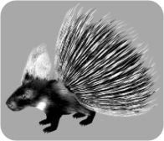

**A.** mane of a lion

**B.** feathers of a peacock

**C.** fur of a polar bear

**D.** shell of a tortoise

**6. Here are some properties of an object:**

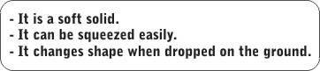

**A.** A pillow

**B.** A cube of ice

**C.** A glass bottle

**D.** A lump of wet clay

**7. The following words are used to describe different substances. Materials that can be stretched into wires are called DUCTILE. Materials that break easily are called BRITTLE. Materials that are soft and can be beaten into sheets are called MALLEABLE. Shyam dropped his ice-cream cup and it broke into pieces because it was __________.**

**A.** malleable

**B.** ductile

**C.** brittle

**D.** all of the above

**8. Prabha puts a thermometer in a beaker with cold water.**

**The mercury level gives the temperature of the water. What will happen to the mercury level in the thermometer if she takes it out of a beaker of cold water and puts it in a beaker of hot water?**

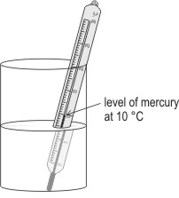

**A.** It will rise.

**B.** It will fall down.

**C.** It will remain at the same place.

**D.** It will change only if the water is boiling.

**9. Shown here is a label found on a strip of tablets. Which of the circled areas indicates the amount of medicine present in one tablet?**

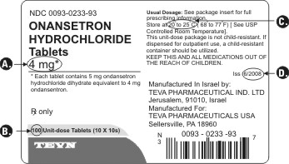

**10. What could be the use of the instrument shown here?**

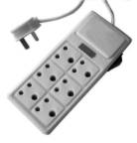

**A.** To heat water, as an electric heater.

**B.** As a remote control for toy cars.

**C.** As a battery for some types of toys.

**D.** To provide power to more than 1 device.

**11. Malini has lost her bicycle key and wants to use a car key to unlock her bicycle. Her father tells her that she cannot unlock the bicycle with the car key because it is different in some ways. Which of these differences do not allow the car key to unlock the bicycle?**

**A.** Its size and shape.

**B.** Its size and colour.

**C.** Its shape and weight.

**D.** Its shape and material.

**12. Neeta's fingers got burnt when she touched a hot vessel by mistake. What should she do**

**IMMEDIATELY?**

**A.** Tie a handkerchief tightly around her fingers.

**B.** Keep the burnt fingers under running water.

**C.** Apply an ointment and keep rubbing her fingers.

**D.** Do nothing till the doctor comes.